**Digital System Design Lab**

**LAB # 07**



Submitted by: Maaz Habib

Registration No: 20PWCSE1952

Class Section: **C**

“On my honor, as student of University of Engineering and Technology, I have neither given nor received unauthorized assistance on this academic work.”

Submitted to:

**Eng:Muhammad Usman**

**Department of Computer Systems Engineering**

**University of Engineering and Technology, Peshawar**

**Lab # 07**

**a.** Desgin/Implementing a 3-bit Up/Down Counter and Displaying the Output Count on LEDs **b.** Desgin/Implementing a 3-bit Up/Down Counter and Displaying the Output Count on a Seven Segment Display

TASK1:

COUNTER

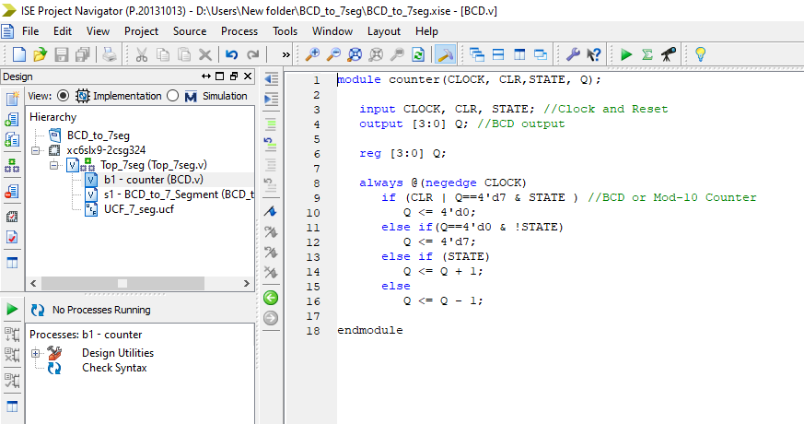

BCD TO SEVEN SEGMENT

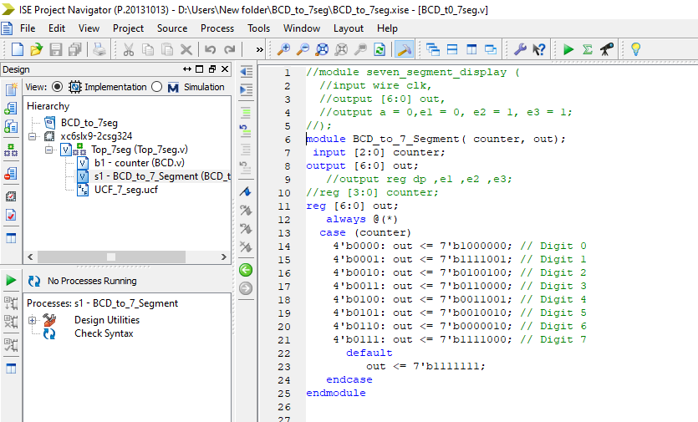

TOP

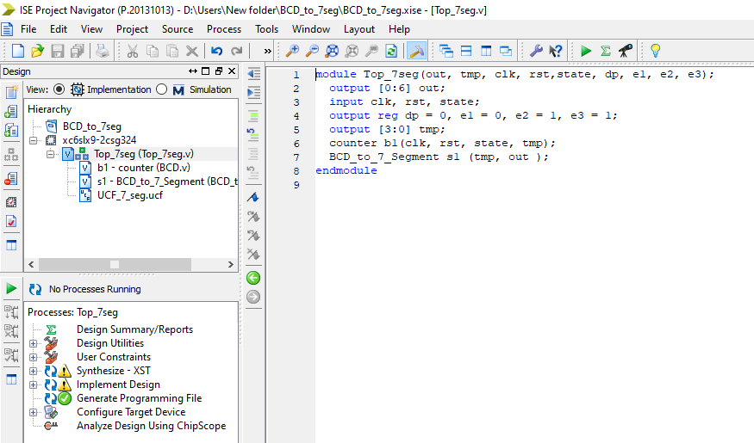

UCF:

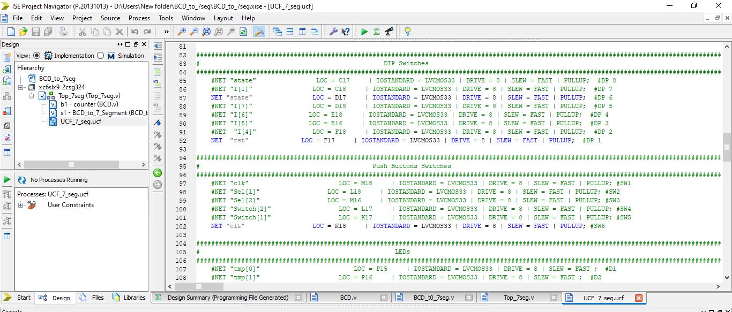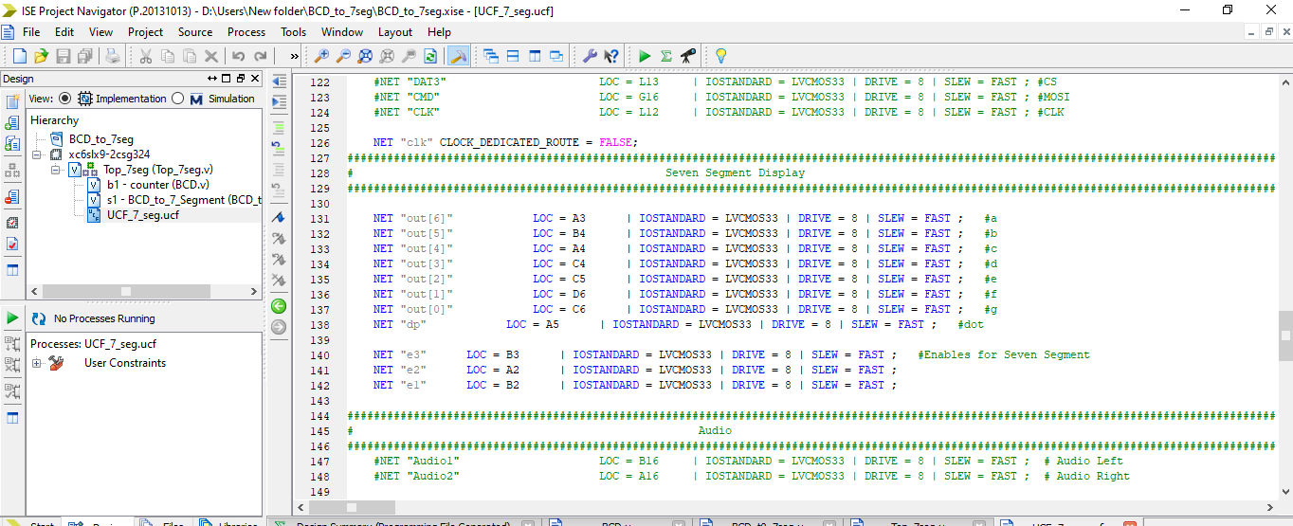

FPGA:

